MINI PROJECT REPORT
ON
IT Equipment Maintenance Management System
SUBMITTED TO


IN PARTIAL FULFILLMENT OF THE REQUIREMENT
FOR THE AWARD OF THE DEGREE
“BACHELOR OF COMPUTER APPLICATION”
Batch: Jan 2024
Semester V
Session 2024-27

Submitted by:  SOURAV DEY  Student Name  Roll No.: 2323000566 | Supervised by:  Ms. Shreyi Mittal  Professor  CDOE, GLA University


CDOE, GLA University

CERTIFICATE
This is to certify that the project report entitled “Employee Record Management”, is submitted by Mr. Sourav Dey (Roll no. 2323000566) student of Bachelor of Computer Application, CDOE, GLA University, under my supervision for the partial fulfillment for the award of the Degree, CDOE, GLA University, Session 2024-27, Batch Jan 2024.
Place: Mathura
Date: 20-12-2025

Supervisor: Prof. Shreyi Mittal

CDOE, GLA University
……………..……………...... Name: SOURAV DEY
Name & Signature of Supervisor Course: Bachelor of Computer Application University Roll No: 2323000566


CDOE, GLA University

DECLARATION

I Sourav Dey, student of Bachelor of Computer Application (V Semester), Session 2024-2027, Batch Jan, 2024 hereby declare that my work entitled “IT Equipment Maintenance Management System”, is the outcome of genuine efforts done by me under the able guidance of Ms. Shreyi Mittal and being submitted to CDOE, GLA University, as mini project report in partial fulfillment for the award of the degree.

Place: Kolkata
Date: 23-04-2026  Name & Signature of
Name: SOURAV DEY
Course: Bachelor of Computer Application University Roll No: - 2323000566


CDOE, GLA University

ACKNOWLEDGEMENT

Firstly, I would like to express my sincere gratitude to thank Mr. Aditya Tiwari , Professor GLA university who supervised my project. Under her unrelated support and guidance, my project has taken this shape.
I am equally indebted to my family and friends who always inspired and motivated me to do something better throughout this project.
At last, I would like to extend my sincere thanks to all the respondents to whom I visited for giving their support and valuable information, which helps me in completing my project work.

Name: SOURAV DEY

Course: Bachelor of Computer Application

University Roll No. -2323000566


CDOE, GLA University

Abstract
The Employee Record Management System is a web-based application developed to efficiently manage employee information in a digital environment. The primary goal of this project is to replace traditional manual record-keeping methods with an automated, reliable, and user-friendly system. The application enables users to perform essential operations such as adding, updating, deleting, and searching employee records with ease. Each employee record contains key details including employee name, employee ID, department, and salary.
The system is developed using core web technologies such as HTML for structure, CSS for styling and responsive design, and JavaScript for functionality and data handling. To ensure data persistence without the need for a backend server or database, browser-based localStorage is used to store employee records securely. The project also includes advanced features such as real-time search functionality and data export options, allowing users to export employee records in Excel (CSV) and PDF formats for reporting and documentation purposes.
The Employee Record Management System provides a simple yet effective solution for small organizations, educational purposes, and beginners in web development. It demonstrates the practical implementation of CRUD operations and client-side storage while offering a clean and interactive user interface. Overall, the project highlights how modern web technologies can be used to build efficient management systems with minimal resources.

Table of Contents
CERTIFICATE | II
DECLARATION | III
ACKNOWLEDGEMENT | IV
ABSTRACT | V
TABLE OF CONTENTS | VI-VII
- INTRODUCTION  - Project Overview  - Purpose and Motivation  - Project Objective | 1-4  2  2  3 &4
2. Software Requirement Analysis  2.1 Problem Definition for Employee Record Management  2.2 Modules and Their Functionalities | 5-10  5,6  7 & 8
3. Software Design  - Architecture Overview  - Component Design  - User Interface Design  - Data flow Design  - Sequence Diagram  - Error Handling Design | 8-10  9  9  10  10  10  10
- Testing  4.1 TEST CASES  4.2 TEST AND THEIR RESULTS | 11-13  11 &12  13
- Implementation and User Interface  - Here comes my HTML Structure  - Here comes my CSS Structure  - Here comes my JavaScript Structure  - User Interface | 14-47  14-18  19-34  35-46  47
6. References/Bibliography of Project | 48
7. Appendices of the Project | 49,50 & 51
8. Conclusion of the Project | 51

- Introduction: -
In today’s digital era, effective management of employee information is essential for the smooth functioning of any organization. Many small and medium-sized organizations still rely on manual methods or basic spreadsheet tools to maintain employee records, which often results in data redundancy, errors, and difficulties in data retrieval. To overcome these challenges, an automated system is required that can store, manage, and retrieve employee data efficiently.
The Employee Record Management System is a web-based application designed to simplify the process of managing employee information. This system allows users to maintain records such as employee name, employee ID, department, and salary in a structured and organized manner. The application provides essential features including adding new employee records, editing existing information, deleting outdated records, and searching for specific employees quickly.
The project is developed using standard web technologies such as HTML, CSS, and JavaScript, making it lightweight, responsive, and easy to deploy. It uses browser localStorage to store employee data, ensuring data persistence without the need for a backend server or database. The system also supports data export in Excel and PDF formats, enabling easy reporting and documentation.
Overall, the Employee Record Management System offers a practical solution for efficient employee data management and serves as a valuable learning project for understanding client-side web application development.
Managing employee records manually or through basic spreadsheet systems is time-consuming and prone to errors. Traditional methods often lead to problems such as data redundancy, difficulty in updating records, lack of proper search functionality, and risk of data loss. As organizations grow, maintaining accurate employee information becomes increasingly challenging without a structured and automated system.

  - Project Overview: -

The Employee Record Management System is a web-based application that helps manage employee details efficiently. It allows users to add, update, delete, search, and export employee records using a simple interface built with HTML, CSS, and JavaScript, with data stored in browser localStorage.

  - Purpose and Motivation: -
The purpose of the Employee Record Management System is to provide a simple and efficient solution for managing employee information in a digital format. The project aims to reduce the dependency on manual record keeping and minimize errors associated with traditional methods. The motivation behind developing this system is the growing need for fast, reliable, and easily accessible data management tools, especially for small organizations and academic use. This project also serves as a practical implementation of web development concepts, demonstrating the use of client-side technologies to build a functional and user-friendly management system.

  - Project Objective: Employee Record Management

Purpose: The purpose of the Employee Record Management System is to provide a simple and efficient way to manage employee information digitally. It aims to reduce manual work, minimize errors, and allow easy storage, retrieval, and export of employee records using a user-friendly web-based application.

Key Features:
Add Employee Records:
Allows users to enter employee details such as name, ID, department, and salary, storing the information securely for easy access and management.

Edit Employee Details:
Enables modification of existing employee records, ensuring updated and accurate information without deleting or re-entering the entire record.
Delete Employee Records:
Provides the option to remove outdated or incorrect employee data permanently, helping maintain a clean and organized record system.

Search Functionality:
Allows users to quickly find employee records by name or employee ID, improving efficiency and saving time during data retrieval.

Local Storage Support:
Stores employee data in the browser’s localStorage, ensuring data persistence even after refreshing or closing the browser.

Technical Implementation:
Utilize HTML, CSS, and JavaScript to build the application for user.

Export to Excel:
Individuals seeking daily motivation, inspiration, or a simple way to share uplifting messages with others.

Export to PDF:
Generates a well-formatted PDF document of employee records, useful for reporting, documentation, and official record maintenance.

- Software Requirement Analysis

2.1 Problem Definition for Employee Record Management

1. Core Problem:
The core problem addressed by this project is the inefficiency and unreliability of manual employee record management. Traditional methods are time-consuming, error-prone, and lack proper search and update features, making it difficult to store, manage, and retrieve employee information efficiently.

2. Specific Problems:
- Manual Data Handling:
Maintaining employee records manually requires significant time and effort. Paper-based or spreadsheet systems increase the chances of human errors, data duplication, and misplacement of important employee information.
- Difficulty in Updating Records:
Updating employee details in traditional systems is inconvenient and error-prone. Changes often require rewriting or modifying multiple entries, leading to inconsistencies and outdated employee information.

- Lack of Efficient Search:
Manual systems do not provide quick search functionality. Finding specific employee records becomes time-consuming, especially as the number of employees increases.
- Risk of Data Loss:
Employee records stored manually or in unsecured files are vulnerable to loss due to accidental deletion, system failure, or physical damage, with no proper backup mechanism.

- No Export or Reporting Facility:
Traditional record-keeping methods lack built-in options to generate reports or export data, making it difficult to share employee information or maintain official documentation efficiently.
- Limited Accessibility:
Manual or offline record systems restrict access to employee information to a single location or device. This makes it difficult for authorized users to retrieve or update data quickly when required.

- Poor Data Organization:

Traditional systems often lack proper structure, resulting in unorganized and scattered employee records. This reduces clarity, increases confusion, and makes long-term data management inefficient.

- Scalability Issues:
As the number of employees increases, manual record-keeping systems become difficult to manage. Handling large volumes of data without automation leads to slower operations and reduced system efficiency.

3. Impact of the Problems:
The identified problems lead to inefficiency, increased workload, and higher chances of errors in managing employee records. Delays in data retrieval, loss of important information, and lack of proper reporting negatively affect organizational productivity, decision-making, and overall data reliability, especially as the number of employees grows.

2.2 Modules and Their Functionalities
The Employee Record Management application can be divided into several key modules, each responsible for specific functionalities. Below is a detailed breakdown of these modules:
• Employee Input Module:
This module is responsible for collecting employee details such as name, employee ID, department, and salary through a user-friendly form. It validates input data and ensures accurate information is entered before storing it.

• Data Storage Module:
The data storage module uses browser localStorage to save employee records in a structured format. It ensures data persistence so that employee information remains available even after refreshing or closing the browser.

• Employee Display Module:
This module retrieves stored employee records and dynamically displays them in a tabular format. It updates the table in real time whenever records are added, edited, or deleted.

• Edit Module:
The edit module allows users to modify existing employee records. It loads the selected employee’s data back into the input form, enabling quick updates without re-entering all details.

• Delete Module:
This module provides functionality to remove employee records permanently from the system. It helps maintain accurate and up-to-date records by eliminating outdated or incorrect data.

• Search Module:
The search module enables real-time filtering of employee records based on employee name or ID. It improves efficiency by allowing users to quickly locate specific records.

• Export to Excel Module:
This module converts employee data into CSV format and allows users to download it as an Excel file. It is useful for data backup, sharing, and further analysis.

• Export to PDF Module:
The PDF export module generates a well-formatted document containing all employee records. It supports reporting and official documentation by allowing users to download employee data in PDF format.

- Software Design
The software design of the Employee Record Management System describes the overall structure, components, and interactions required to implement the system functionalities. This section explains the system architecture, component design, user interface design, and data flow used in the application.

3.1 Architecture Overview

Client-Side Architecture:
The Employee Record Management System follows a client-side architecture where all operations are performed within the web browser. The application handles user interactions, data processing, and data storage without requiring a backend server. Employee data is stored using the browser’s localStorage, ensuring persistence across sessions.
The browser acts as both the user interface and data handler, making the system lightweight, fast, and easy to deploy.

3.2 Component Design

I. Frontend Components
- HTML Structure:
Defines the layout of the application, including the employee input form, search bar, action buttons, and employee record table.
- CSS Styling:
Provides a clean, modern, and responsive design. CSS ensures proper alignment, visual clarity, and compatibility across different screen sizes.
- JavaScript Logic:
Implements core functionalities such as adding, editing, deleting, searching employee records, managing localStorage, and exporting data to Excel and PDF formats.

II. Data Storage Component
- Local Storage:
Uses the browser’s localStorage to store employee records in JSON format. This allows data to remain available even after refreshing or closing the browser.

3.3 User Interface Design
Main Interface Elements:
- Employee Input Form:
Allows users to enter employee name, ID, department, and salary.
- Action Buttons:
Includes buttons for adding, updating, deleting employee records, and exporting data.
- Search Box:
Enables real-time filtering of employee records by name or ID.
- Employee Table:
Displays all employee records in a structured and readable tabular format.
Visual Design:
The interface uses a responsive layout with clear typography and color contrast to enhance usability across desktops, tablets, and mobile devices.

3.4 Data Flow Design
Data Flow Description:
- User enters employee details and submits the form.
- JavaScript validates and processes the input data.
- Employee records are stored in localStorage.
- Stored data is retrieved and displayed in the table.
- User actions such as edit, delete, search, or export update the displayed data accordingly.

3.5 Sequence Diagram (Employee Record Operations)
- User enters employee details and clicks “Add Employee”.
- Application validates the input data.
- Data is stored in localStorage.
- Employee list is updated dynamically.
- User can edit, delete, search, or export records.

3.6 Error Handling Design
- Input validation ensures no empty.

4. Testing
Testing is performed to ensure that all functionalities of the Employee Record Management System work correctly and meet the specified requirements. Various test cases were designed and executed to validate data input, record management, search functionality, and export features.

4.1 Test Cases

Test Case 1: Add Employee Record
- Objective: Verify that a new employee record can be added successfully.
- Steps:
• Open the application.
• Enter employee name, ID, department, and salary.
• Click the “Add Employee” button.
- Expected Result: The employee record is added and displayed in the employee list table.

Test Case 2: Edit Employee Record
- Objective: Ensure that existing employee details can be updated.
- Steps:
• Select an employee record.
• Click the “Edit” button.
• Modify the details and submit.
- Expected Result: The employee record is updated successfully in the table.

Test Case 3: Delete Employee Record
- Objective: Verify that an employee record can be deleted.
- Steps:
• Select an employee record.
• Click the “Delete” button.
- Expected Result: The selected employee record is removed from the list.

Test Case 4: Search Employee Record
- Objective: Ensure the search functionality works correctly.
- Steps:
• Enter employee name or ID in the search box.
- Expected Result: Matching employee records are displayed instantly.

Test Case 5: Data Persistence Using Local Storage
- Objective: Verify that employee data is stored permanently.
- Steps:
• Add employee records.
• Refresh or reopen the browser.
- Expected Result: Previously added employee records are retained and displayed.

Test Case 6: Export Employee Records to Excel
- Objective: Ensure employee data can be exported in Excel (CSV) format.
- Steps:
• Click the “Export to Excel” button.
- Expected Result: Employee records are downloaded as a CSV file.

Test Case 7: Export Employee Records to PDF
- Objective: Verify PDF export functionality.
- Steps:
• Click the “Export to PDF” button.
- Expected Result: A PDF file containing employee records is generated and downloaded.

Test Case 8: Real-Time Date and Time Display
- Objective: Verify that current date and time are displayed correctly.
- Steps:
• Open the application.
• Observe the date and time section.
- Expected Result: The date and time are displayed correctly and update automatically in real time.

4.2 Tests and Their Results
Test Case | Description | Status
Test Case 1 | Add Employee Record | ☑ Passed
Test Case 2 | Edit Employee Record | ☑ Passed
Test Case 3 | Delete Employee Record | ☑ Passed
Test Case 4 | Search Employee Record | ☑ Passed
Test Case 5 | Data Persistence | ☑ Passed
Test Case 6 | Export to Excel | ☑ Passed
Test Case 7 | Export to PDF | ☑ Passed
Test Case 8 | Date & Time Display | ☑ Passed

- Implementation and User Interface
Implementation Overview
The Employee Record Management System is implemented using HTML, CSS, and JavaScript to provide a dynamic and interactive web application. It allows users to manage employee records efficiently through CRUD operations, real-time search, and data export features, with employee data securely stored using browser localStorage for persistence.

- Here comes my HTML Structure ::
  - Document Declaration and Language 
- <!DOCTYPE html>
Declares the document type and specifies that the application is built using HTML5, ensuring proper rendering and compatibility across modern web browsers.
- <html lang="en">
Defines the root element of the HTML document and sets the language to English, which helps browsers and assistive technologies improve accessibility, readability, and search engine optimization.

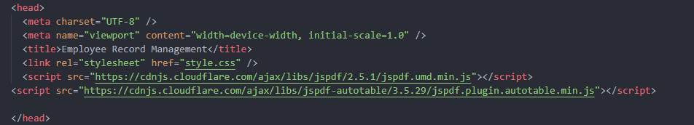
  - Head Section
- <head>
Contains metadata and external resource links required for proper functioning and presentation of the web application.
- <meta charset="UTF-8">
Specifies UTF-8-character encoding to support a wide range of characters and symbols.
- <meta name="viewport" content="width=device-width, initial-scale=1.0">
Ensures the application is responsive and displays correctly on different screen sizes and devices.
- <title>
Sets the title of the web page, displayed on the browser tab as Employee Record Management.
- <link rel="stylesheet" href="style.css">
Links the external CSS file responsible for styling and layout design of the application.
- jsPDF Library Script
Enables generation of PDF documents from employee data.
- jsPDF AutoTable Plugin
Supports structured table formatting inside the generated PDF files

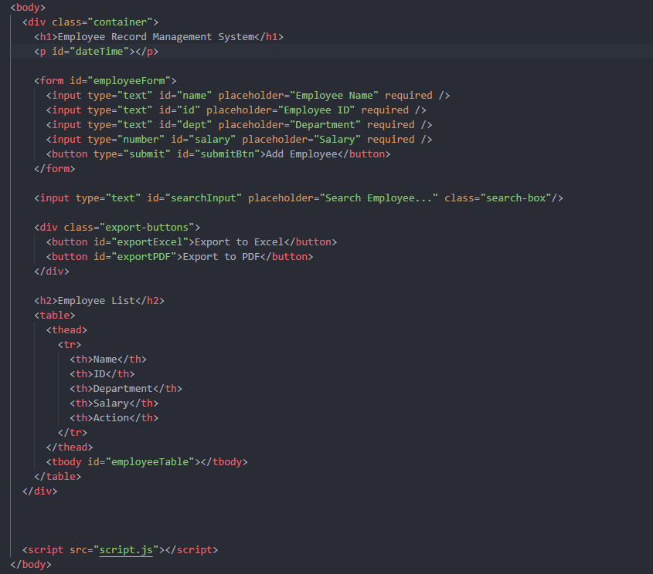
  - Body Section

- Container Division:
Acts as the main layout wrapper that organizes all elements of the application, ensuring proper alignment, spacing, and a clean, structured user interface.

- Application Heading:
Displays the title of the system, clearly informing users about the purpose of the application and improving overall readability and identification.

- Date and Time Display:
Dynamically shows the current date and time, helping users monitor real-time activity and improving the usability of the system.

- Employee Input Form:
Collects employee details such as name, ID, department, and salary, ensuring all required information is entered before submission.

- Submit Button:
Allows users to add new employee records or update existing records efficiently through a single action.

- Search Input Field:
Enables users to quickly search employee records by name or ID, reducing manual effort and improving data retrieval speed.

- Export Buttons Section:
Provides options to export employee records into Excel and PDF formats for reporting, backup, and documentation purposes.

- Employee List Table:
Displays all employee records in a tabular format, making data organized, readable, and easy to manage.

- External JavaScript Link:
Connects the HTML structure with JavaScript logic, enabling dynamic functionality and interactive behavior of the application.

The HTML code provides the structural framework of the Employee Record Management System. It defines the overall layout of the web application, including the main container, heading, date and time display, employee input form, search field, export buttons, and employee record table. Each input field is designed to collect essential employee details such as name, ID, department, and salary with proper validation. The table structure organizes employee records in a clear and readable format, while action buttons enable user interaction. By linking external CSS and JavaScript files, the HTML code ensures proper styling, responsiveness, and dynamic functionality, resulting in a well-structured and user-friendly web application.

This wraps up my HTML structure

- Here comes my CSS structure:
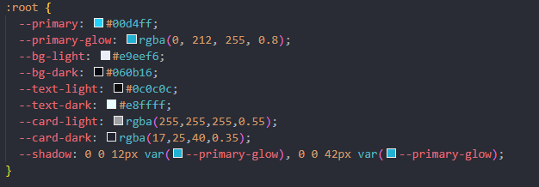
CSS Root Variables and Theme Configuration

- Root Selector:
The :root selector defines global CSS variables, allowing consistent styling values to be reused throughout the entire application.

- Primary Color Variable:
Defines the main theme color used for headings, buttons, and highlights, ensuring a uniform visual identity.

- Primary Glow Effect:
Creates a glowing visual effect using RGBA values, enhancing button and text appearance.

- Background Color Variables: Specifies light and dark background colors to improve readability and overall user experience.

- Text Color Variables:
Controls text colors for light and dark themes, ensuring proper contrast and accessibility.

- Card Background Variables:
Defines semi-transparent card backgrounds to achieve a modern glassmorphism design effect.

- Shadow Variable:
Creates reusable shadow effects for UI elements, adding depth and visual emphasis to the interface.
Dark Mode Styling Configuration

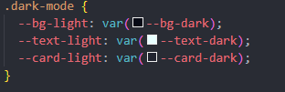

- Dark Mode Class:
The .dark-mode class enables dark theme styling by overriding default CSS variables when activated.

- Background Color Switch:
Replaces the light background color with the dark background variable for better visibility in low-light conditions.

- Text Color Adjustment:
Changes text color to a lighter shade to maintain readability against dark backgrounds.

- Card Background Update:
Updates card background colors to darker tones, ensuring visual consistency across all UI components.
Body Styling and Global Layout Design

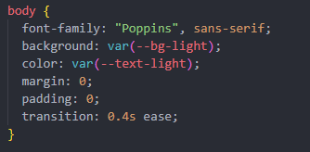

- Font Family:
Sets the default font to Poppins with a sans-serif fallback, ensuring clean and modern typography throughout the application.

- Background Color:
Applies the global background color using CSS variables, supporting both light and dark theme modes.

- Text Color:
Defines the default text color for improved readability and consistent appearance across all sections.

- Margin and Padding Reset:
Removes default browser margins and padding to maintain uniform spacing and layout control.

- Smooth Transition Effect:
Adds a smooth transition effect for theme changes, enhancing the visual experience during mode switching.

Container Styling and Layout Configuration
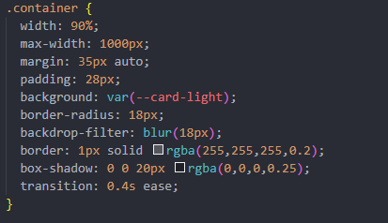

- Width and Max-Width:
Sets a responsive container width with a maximum limit, ensuring proper display on both large and small screens.

- Center Alignment:
Uses automatic margins to center the container horizontally within the page layout.

- Padding:
Adds internal spacing to prevent content from touching the container edges, improving readability.

- Background Styling:
Applies a semi-transparent card background using CSS variables, supporting light and dark themes.

- Rounded Corners:
Uses border-radius to create smooth, modern rounded edges for the container.

- Backdrop Blur Effect:
Applies a blur effect behind the container, creating a glassmorphism design appearance.

- Border Styling:
Adds a subtle border to enhance container separation from the background.

- Box Shadow:
Creates depth by adding a soft shadow around the container.

- Smooth Transition:
Enables smooth visual transitions during theme or layout changes.

Heading Styling (h1 and h2)
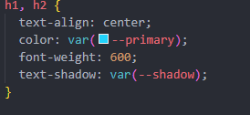

- Text Alignment:
Centers the main and subheadings, improving visual balance and focus.

- Theme Color:
Applies the primary theme color to headings for consistent branding and emphasis.

- Font Weight:
Sets a semi-bold font weight to make headings more prominent and readable.

- Text Shadow Effect:
Adds a glowing shadow effect using CSS variables, enhancing the visual appeal of headings.

Form Layout Styling
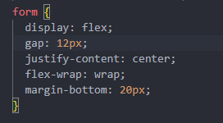

- Flex Display:
Uses flexbox to arrange form elements in a flexible and organized horizontal layout.

- Element Spacing:
Adds spacing between input fields using the gap property for a clean appearance.

- Center Alignment:
Centers form elements horizontally within the container for better visual balance.

- Responsive Wrapping:
Allows input fields to wrap onto the next line on smaller screens, ensuring responsiveness.

- Bottom Margin:
Adds spacing below the form to separate it from other page elements.

Input Field Styling
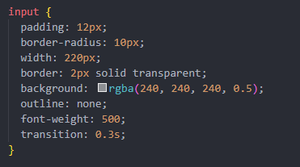

- Padding:
Adds internal spacing to input fields, improving text readability and user comfort.

- Rounded Corners:
Applies smooth rounded edges to input fields for a modern appearance.

- Fixed Width:
Sets a consistent width for input fields, maintaining uniform alignment in the form.

- Transparent Border:
Uses a transparent border to prevent layout shift when focus styles are applied.

- Background Color:
Applies a semi-transparent background to enhance visibility and match the design theme.

- Outline Removal:
Removes the default browser outline for a cleaner look.

- Font Weight:
Sets medium font weight for better text clarity.

- Transition Effect:
Adds smooth visual transitions during hover or focus interactions.

Input Focus Styling
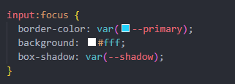

- Border Color Change:
Highlights the active input field using the primary theme color, improving user focus and visibility.

- Background Color Update:
Changes the background to white when focused, enhancing text clarity during data entry.

- Box Shadow Effect:
Applies a glowing shadow effect to indicate the selected input field and improve user interaction feedback.

Search Box Styling
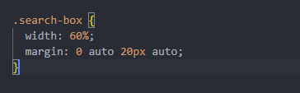

- Adjusted Width:
Sets the search box width to 60%, making it wider than other inputs for better visibility and usability.
- Center Alignment:
Uses automatic margins to center the search box horizontally within the container.
- Bottom Spacing:
Adds margin below the search box to separate it visually from other elements and improve layout clarity.

Button Styling and Hover Effects
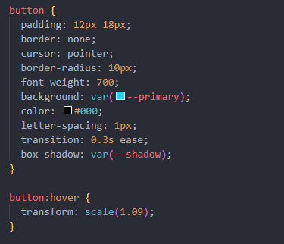

- Padding and Shape:
Provides adequate padding and rounded corners, making buttons comfortable to click and visually appealing.
- Border Removal:
Removes default button borders for a clean and modern appearance.
- Cursor Style:
Changes the cursor to a pointer, indicating clickable elements to users.
- Font Styling:
Uses bold font weight and letter spacing to improve button text visibility.
- Background and Text Color:
Applies the primary theme color with contrasting text for better readability.

- Shadow Effect:
Adds a glowing shadow using CSS variables, enhancing button prominence.
- Hover Animation:
Slightly scales the button on hover, providing interactive visual feedback to users.
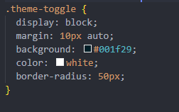
Theme Toggle Button Styling

- Display Property:
Displays the theme toggle button as a block element, allowing proper spacing and alignment.
- Center Alignment:
Uses automatic margins to center the button horizontally within the page layout.
- Background Color:
Applies a dark background color to distinguish the toggle button from other controls.
- Text Color:
Sets white text color for clear contrast against the dark background.
- Rounded Shape:
Uses a high border-radius value to create a pill-shaped, modern toggle button.

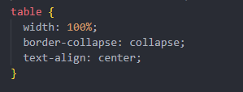
Table Layout Styling

- Full Width:
Sets the table width to 100%, ensuring it occupies the available container space for better data visibility.
- Border Collapse:
Collapses table borders into a single border, creating a clean and compact table layout.
- Centre Text Alignment:
Aligns table content to the centre, improving readability and uniform presentation of employee data.
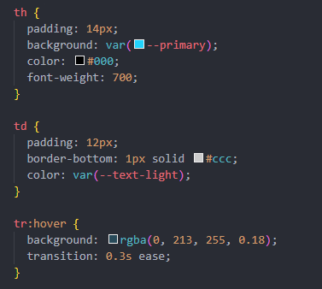
Table Header, Data Cells, and Row Hover Effects

- Table Header Styling (th):
Applies padding, bold font weight, and the primary theme color to table headers, making column titles clear and visually distinct.
- Table Data Styling (td):
Adds padding and bottom borders to table cells, improving readability and clearly separating employee records.
- Row Hover Effect (tr:hover):
Highlights table rows when hovered, providing visual feedback and improving user interaction and navigation.

Edit and Delete Button Styling

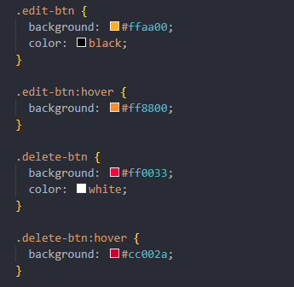

- Edit Button Styling:
Uses a distinct orange background with dark text to clearly indicate the edit action and differentiate it from other buttons.
- Edit Button Hover Effect:
Changes the background color on hover, providing visual feedback to the user during interaction.
- Delete Button Styling:
Applies a red background with white text to represent the delete action, clearly indicating a critical operation.
- Delete Button Hover Effect:
Darkens the red color on hover to emphasize the delete action and improve user awareness.

Responsive Design Using Media Queries
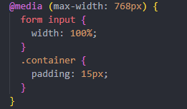

- Media Query Condition:
Applies responsive styles when the screen width is 768 pixels or smaller, ensuring compatibility with tablets and mobile devices.
- Form Input Adjustment:
Sets input fields to full width on smaller screens, improving usability and touch interaction.
- Container Padding Reduction:
Reduces container padding to better fit content on smaller displays while maintaining a clean layout.
This ensures the application remains responsive and user-friendly across all devices.
Date and Time Display Styling
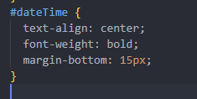

- Center Alignment:
Aligns the date and time text to the center, maintaining visual balance within the application layout.
- Bold Font Weight:
Uses bold text to make the date and time clearly visible to users.
- Bottom Margin:
Adds spacing below the date and time display to separate it from other interface elements

This wraps up my CSS structure
HERE COMES MY JAVASCRIPT STRUCTURE ::
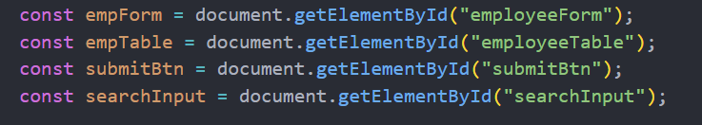
DOM Element Selection

• Employee Form Reference:
Selects the employee input form to handle form submission and data processing using JavaScript.

• Employee Table Reference:
Targets the table body where employee records are dynamically displayed and updated.

• Submit Button Reference:
Accesses the submit button to change its behavior and label during add or update operations.

• Search Input Reference:
Selects the search input field to enable real-time filtering of employee records.

Data Initialization and Edit Tracking
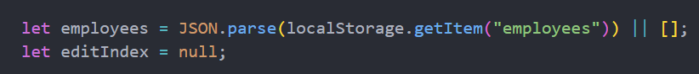
- Employee Data Initialization:
Retrieves stored employee records from browser localStorage. If no data exists, an empty array is initialized to store new records.

- Edit Index Variable:
Maintains the index of the employee record currently being edited, helping differentiate between add and update operations.

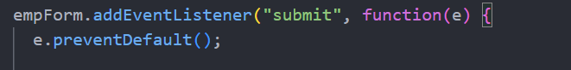
Form Submission Event Handling

• Event Listener Attachment:
Attaches a submit event listener to the employee form to detect when the user submits employee details.

• Prevent Default Behaviour:
Prevents the default form submission and page reload, allowing JavaScript to handle data processing dynamically within the application.

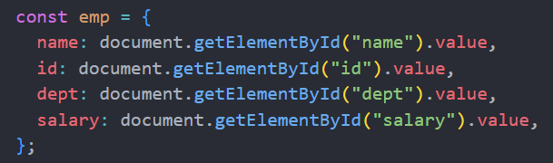
Employee Object Creation

- Employee Data Collection:
Collects values entered in the input fields such as name, ID, department, and salary.

- Object Formation
Stores the collected employee details inside a JavaScript object, making it easier to manage, store, and manipulate employee records.
Add and Update Employee Logic
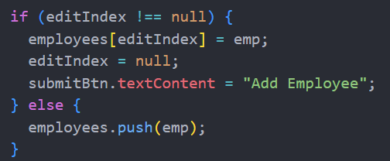

- Edit Condition Check:
Checks whether an employee record is being edited by verifying if the edit index is not null.
- Update Existing Record:
Replaces the selected employee record with updated data and resets the edit mode.

- Button Text Reset:
Changes the submit button text back to “Add Employee” after updating a record.

- Add New Record:
Adds a new employee object to the employees array when not in edit mode.

Data Storage and Interface Update
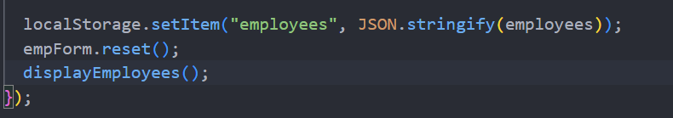

• Local Storage Update:
Saves the updated employees array into browser localStorage in JSON format to ensure data persistence.

• Form Reset:
Clears all input fields after successful submission, preparing the form for new entries.

• Display Refresh:
Calls the display function to update the employee list table with the latest data changes.

Search Functionality Event Handling
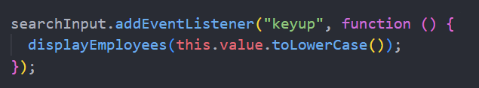

• Keyup Event Listener:
Detects user input in the search box in real time as keys are pressed.

• Case-Insensitive Search:
Converts the search text to lowercase to ensure accurate and case-insensitive filtering of employee records.

• Dynamic Display Update:
Calls the display function to instantly show matching employee records based on the search input.

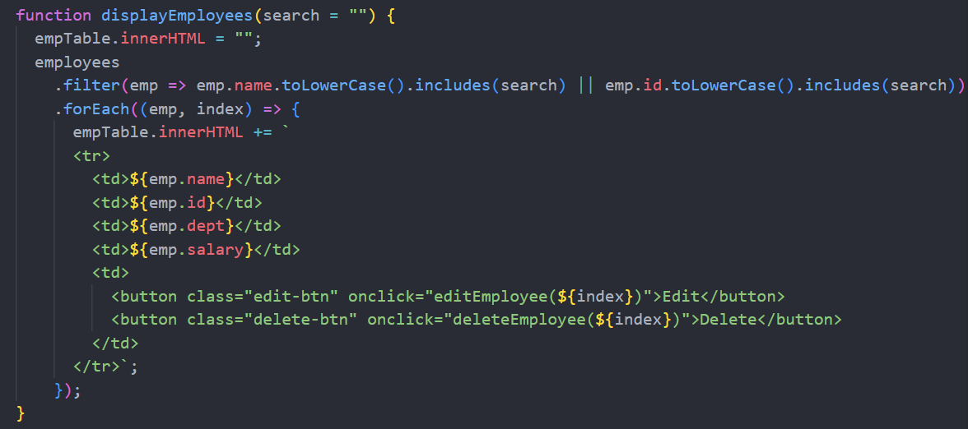
Display Employee Records Function

• Function Initialization:
Defines a function that displays employee records and accepts an optional search parameter for filtering results.
• Table Reset:
Clears existing table rows to prevent duplication before rendering updated employee data.
• Filtering Logic:
Filters employee records based on name or employee ID using case-insensitive matching.
• Dynamic Row Creation:
Generates table rows dynamically for each matching employee record.
• Action Buttons:
Adds edit and delete buttons for each record, enabling record modification and removal.
• Index Tracking:
Passes the employee index to edit and delete functions for accurate record identification.

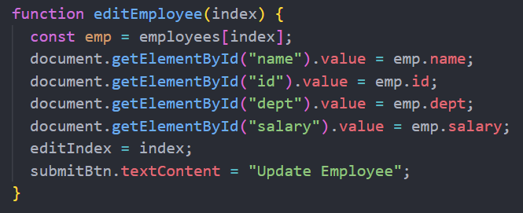
Edit Employee Functionality

• Function Purpose:
Retrieves the selected employee record based on its index for editing.

• Data Population:
Loads the employee’s existing details into the input fields for modification.

• Edit Mode Activation:
Stores the selected index to track the record being edited.

• Button Label Update:
Changes the submit button text to “Update Employee” to indicate edit operation.

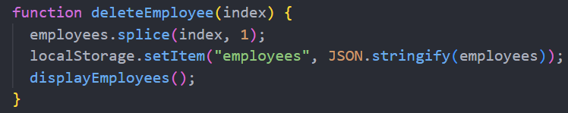
Delete Employee Functionality
- Record Removal:
Removes the selected employee record from the employees array using its index.

- Local Storage Update:
Updates browser localStorage after deletion to maintain accurate and persistent data.

- Table Refresh:
Refreshes the employee list display to reflect the removal of the record immediately.
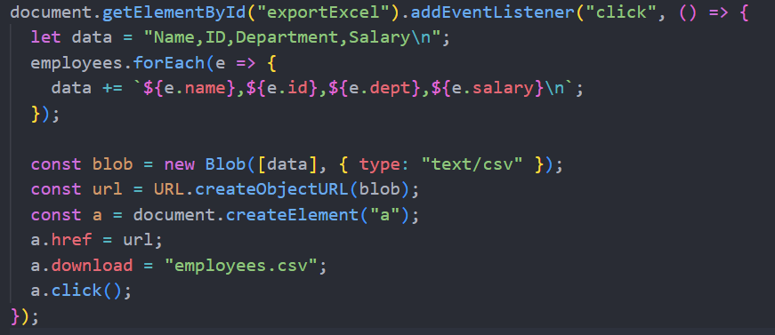
Export Employee Records to Excel (CSV)
• Button Event Listener:
Detects click action on the Export to Excel button.

• CSV Data Creation:
Formats employee data into comma-separated values with appropriate column headers.

• File Generation:
Creates a CSV file using the Blob object for download.

• Automatic Download:
Generates a temporary download link and triggers file download without user intervention.
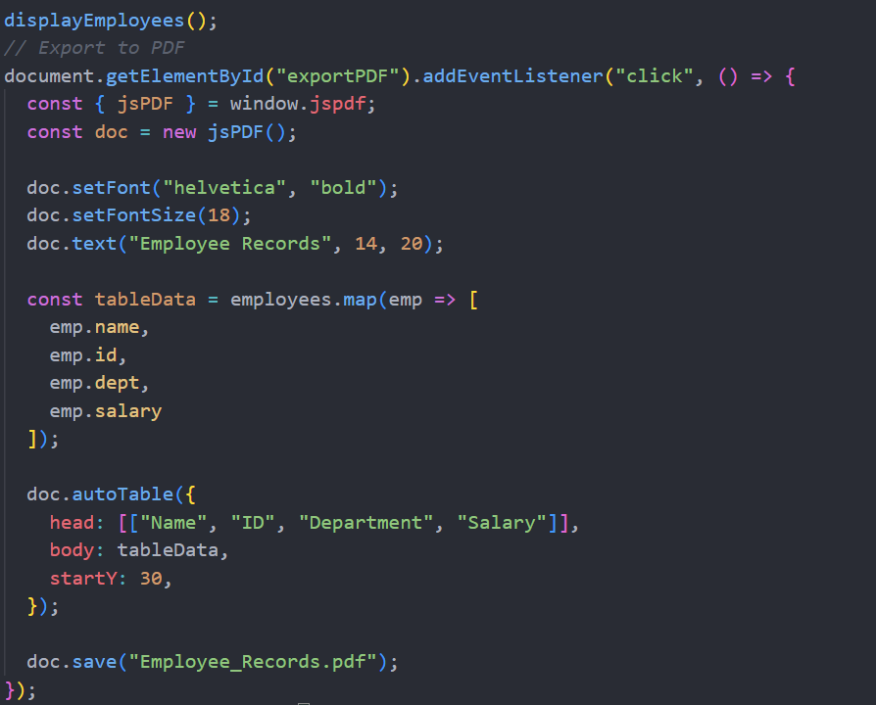
Initial Display and PDF Export Setup

- Initial Table Rendering:
Calls the display function on page load to ensure employee records are shown immediately.

- PDF Export Trigger:
Attaches a click event listener to the Export to PDF button.

- PDF Document Creation:
Initializes a new PDF document using the jsPDF library.

- Title Formatting:
Sets the font style and size, and adds a title heading to the PDF document.

- Table Generation:
Uses the AutoTable plugin to create a structured table containing employee details.

- PDF Download:
Saves the generated document as “Employee_Records.pdf” for user download.

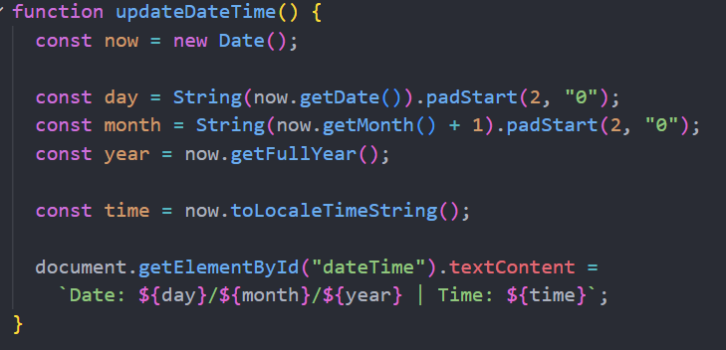
Real-Time Date and Time Function
• Current Date Object:
Creates a new Date object to fetch the current system date and time.

• Custom Date Formatting:
Formats Day and month values with leading zeros and displays the date in DD/MM/YYYY format.

• Time Retrieval:
Extracts the current system time using the locale time format.

• Dynamic Display Update:
Updates the date and time text dynamically in the user interface.

Automatic Date and Time Update Execution
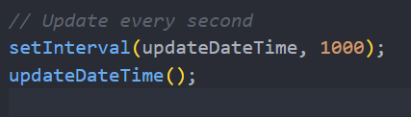

• Interval Setup:
Uses setInterval to call the date and time update function every 1000 milliseconds.

• Real-Time Refresh:
Ensures the displayed date and time update continuously in real time.

• Initial Function Call:
Executes the function immediately when the page loads to avoid any display delay.

THIS WRAPS UP MY JAVASCRIPT PART
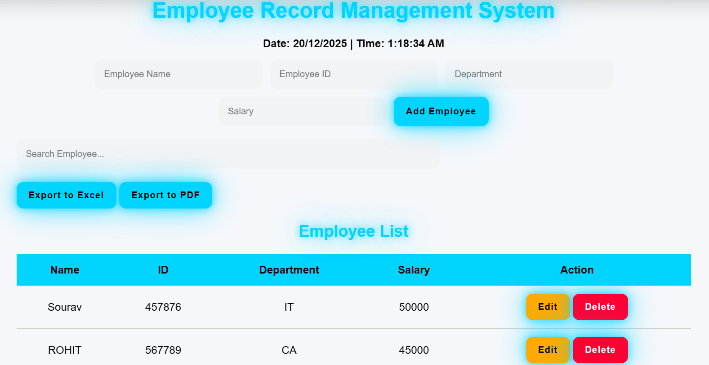
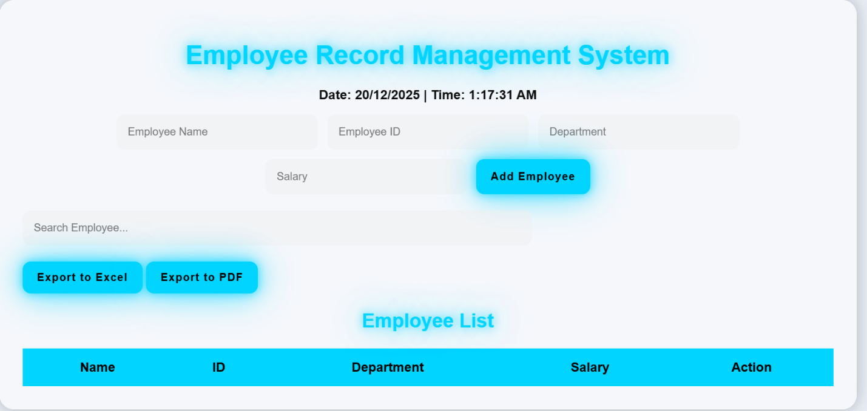
User Interface

- References/Bibliography of Project
- HTML5 Documentation (MDN Web Docs):
Used as a primary reference to understand semantic HTML elements, form handling, and page structure for building a well-organized and accessible web application.

- CSS3 Documentation (MDN Web Docs):
Referenced for learning modern styling techniques, responsive design, CSS variables, and layout management to create an attractive and responsive user interface.

- JavaScript Documentation (MDN Web Docs):
Helped in implementing core application logic such as DOM manipulation, event handling, localStorage usage, and dynamic content updates.

- jsPDF Official Documentation:
Used to implement PDF generation functionality, including document creation, text formatting, and exporting employee records in a structured PDF format.

- W3Schools Web Development Tutorials:
Provided simplified examples and explanations for HTML, CSS, and JavaScript concepts, aiding quick understanding and practical implementation during project development.

- Appendices of the Project
The appendices include supplementary information, screenshots, code snippets, and additional details that support the main content of the Employee Record Management System project report. They provide a practical reference for understanding the system implementation and verifying its functionality.
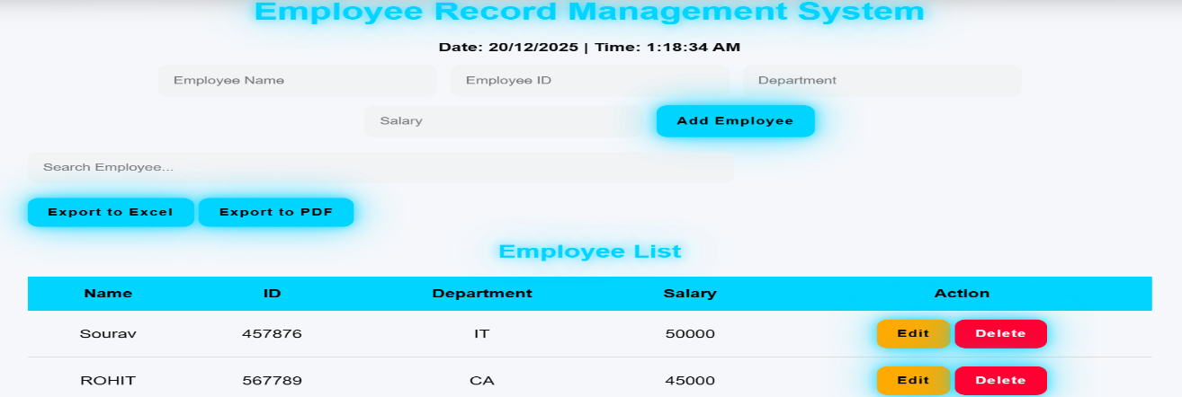
Appendix A: Screenshots of the Application

- Home Page: Displays the main heading, date and time, input form, search bar, and action buttons.
- Adding Employee Record: Shows the form filled with data and the newly added record in the table.
- Editing Employee Record: Illustrates the edit process with the form populated for updating a record.
- Deleting Employee Record: Highlights the removal of a record from the table.
- Export Options: Screenshots of exporting employee data to Excel (CSV) and PDF formats.
- Responsive Design: Screenshots of the application on mobile and tablet screens.



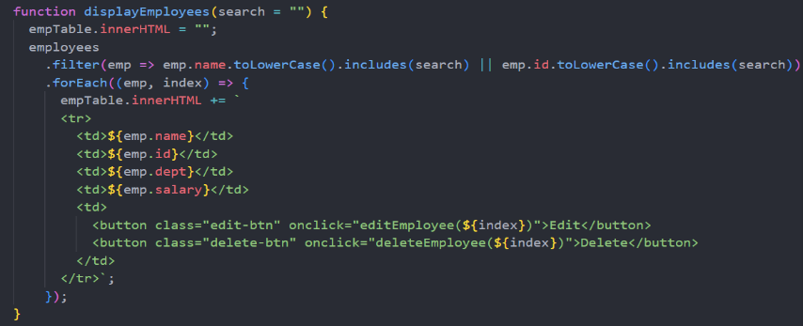


Appendix B: Important Code Snippets


- Employee Object Creation: Captures employee details from the form and stores them in JavaScript objects.
- Display Function: Dynamically renders employee records in a table and handles search filtering.
- Edit & Delete Functions: Manages updating and removing employee records from the list.
- Export Functions: Handles exporting employee data to Excel (CSV) and PDF formats.
- Date and Time Function: Displays real-time date and time dynamically on the interface.

Appendix C: Test Cases and Results
- Detailed test cases for adding, editing, deleting, searching, exporting, and real-time date/time features.
- Includes results confirming all functionalities work as expected.
Appendix D: References
- Documentation for HTML5, CSS3, JavaScript (MDN Web Docs), jsPDF library, and W3Schools tutorials.

- Conclusion of the Project
The Employee Record Management System is a web-based application developed to efficiently manage employee information in a structured and user-friendly manner. The project successfully demonstrates the use of core web technologies—HTML, CSS, and JavaScript—to implement essential functionalities such as adding, updating, deleting, and searching employee records. By leveraging browser localStorage, the system ensures data persistence without requiring a backend server, making it lightweight, fast, and easily deployable.
The system provides additional features such as exporting employee records to Excel (CSV) and PDF formats, which enhances data portability and reporting capabilities. The dynamic search functionality allows users to quickly locate specific employees by name or ID, improving overall efficiency. The real-time display of date and time adds a professional touch and improves user experience.
Moreover, the application is responsive, adapting smoothly to different screen sizes, making it accessible on desktops, tablets, and mobile devices. The modular design and clean interface enhance usability, while proper error handling ensures reliability during interactions.
Overall, the Employee Record Management System achieves its primary objectives by providing an automated solution for employee data management. It reduces manual effort, minimizes errors, and demonstrates practical application of client-side web development concepts. This project serves as a valuable academic exercise and a foundation for future enhancements such as backend integration, authentication, and cloud storage support.


